Chapter 10 Vocabulary
sin  noun- wrong | complimentary  adj – nice
vehemently  adverb - emotionally | inconspicuous  adj.- hard to notice
deserted  adj - empty | accomplishment  noun – something done well

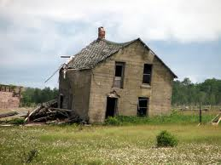
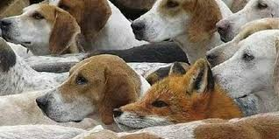 | 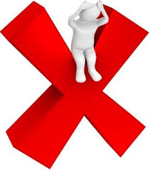

He did not do the things our schoolmates’ fathers did: he never went hunting, he did not play poker or fish or drink or smoke. He sat in the living room and read.
How do you think Jem and Scout felt about their dad?
proud
ashamed
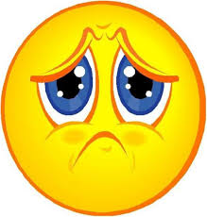
sad

Why does Atticus say it’s a sin to kill a mockingbird?
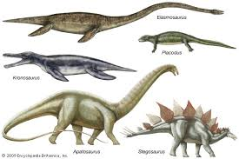
They are almost extinct.
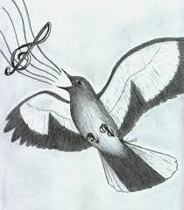
Mockingbirds just sing
and don’t hurt anyone.

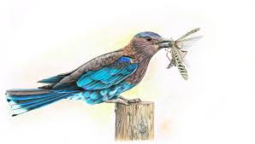
Mockingbirds eat the mosquitos.
“There’s a mad dog down the street and he’s comin’ this way.”
What does the word “mad” mean in this sentence.
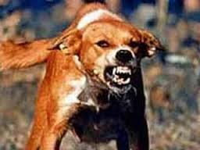
The dog is sick with rabies
and is dangerous.

The dog is angry with its owner.
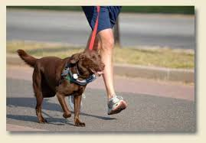
The dog likes to go for walks.

Why did the sheriff ask Atticus to shoot the dog?
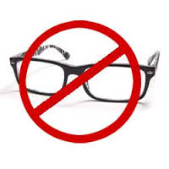
The sheriff didn’t have his glasses.
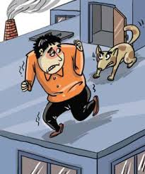
The sheriff was afraid of dogs.
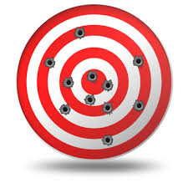
Atticus is a good shot .

How did Jem and Scout feel about Atticus after he shot the dog?
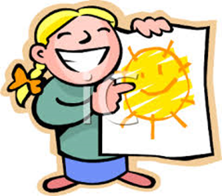
proud
Ashamed
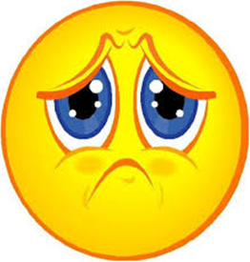
Sad

